Name_________________________________ Date__________________

Period___________ Number_____

Unit 8-3 Notes
Momentum

I. Momentum
  - Momentum is a _____________________________________________.
  - Momentum is the product of the _____________ and ________________ of an object.
  - Momentum = ________________________ x _____________________
  - Momentum is labeled as kg x m/s with a direction
    - For example- kg x m/s east
  - The greater the mass ________________________________________
__________________________________________________________
  - The smaller the mass, the less the velocity, the less the momentum.
    - For example-A baby crawling has less momentum than a car driving at 20 mph.

II. Law of Conservation of Momentum
- __________________________________________________________
- When one moving object collides with another moving object, the motion of both objects change.

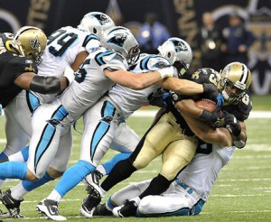

Example: Newton’s Cradle
- The sphere on the left will ____________________________________
____________________________________ through the row of spheres to the sphere on the right.
- The sphere on the right will move and transfer the momentum through the row back to the sphere on the left.
- Newton’s Cradle ____________________________________________
__________________________________________________________

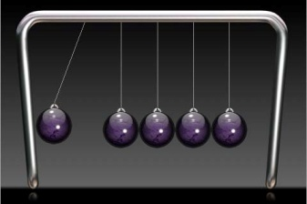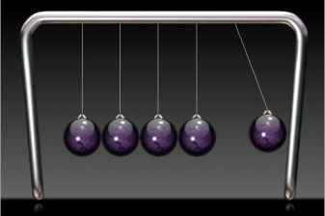
Momentum from the sphere on the left is transferred through the row of spheres to the sphere on the right.

Newton’s Cradle

III. Newton’s 3rd Law and Momentum
  - Newton’s 3rd Law- ___________________________________________________

____________________________________________________________________
  - The first sphere hits the rest of the spheres (____________________________) and transfers the momentum through causing the last sphere to move (___________________________).

