Name_____________________________________ Date________ Pd___ Number _____

Unit 8-1 Motion

I. Gaileo Galilei

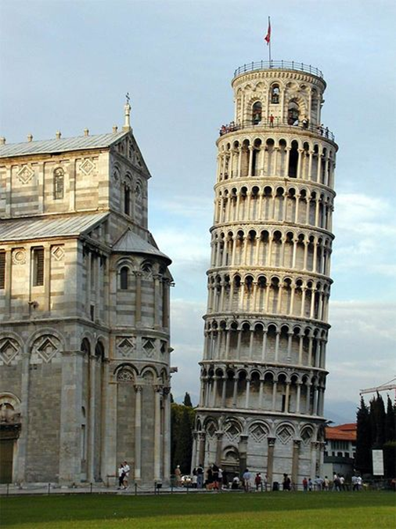
- A scientist who argued that the ________________________________________
____________________________________________________________________________________________________________________________________

- He proved his argument by dropping two cannonballs of different masses off the Leaning Tower of Pisa.

II. Gravity and Acceleration

- Objects fall to the ground at the _________ rate because _________________

due to _______________ is the same for all objects.

- All objects fall toward Earth at the rate of ________________________

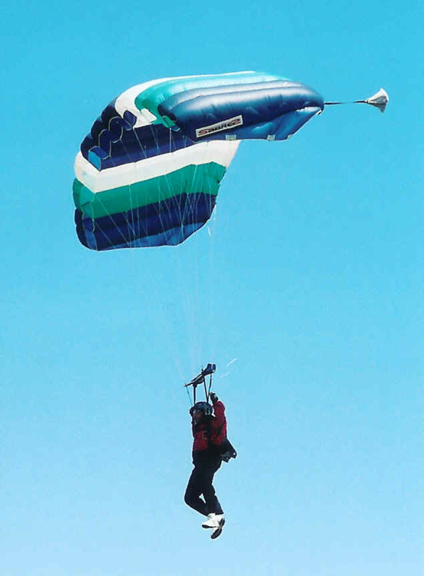
- That means every second an object falls, its velocity _____________ by 9.8 m/s.

III. Air Resistance

- ___________________ is force that ____________ the motion of objects through the air. In other words, it’s ________________________.

- The amount of air resistance acting on an object depends on the _____________________________

__________________________________________

- Terminal Velocity

- Terminal velocity is the __________________ of a falling object when the force of air resistance is equal and opposite in direction to the force of gravity.

- This means that the upward force of air resistance is __________ to the force of gravity and the object slows down.

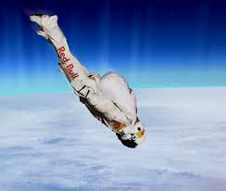
- Free Fall

- Free fall is the ____________ of a body when only the force of gravity is acting on the body.

- In other words, _____________ can only happen if no other forces other than gravity are acting on the object. So, it’s only possible in two places: in a ____________ and in ____________.

- Orbit

- Orbit is when an object _________________________ object.

- Two motions cause orbit:
- The object is moving _______________.
- The object is in ___________________.

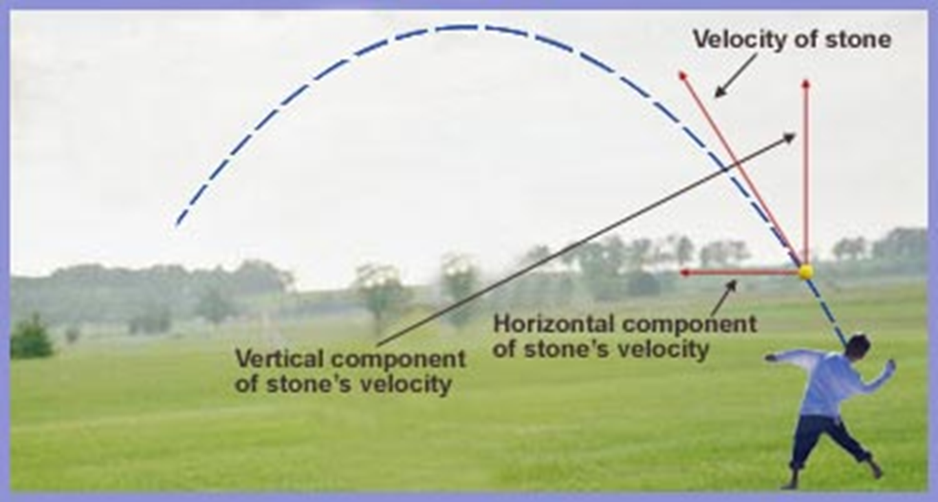
- Projectile Motion

- Projectile motion is the ________________ that an object follows when thrown, launched, or otherwise projected near the surface of Earth.

- Projectile motion depends on two things:
- Horizontal motion
- Vertical motion

- Does the rate of gravity change? __________________________________

- What is gravity’s effect on falling objects?
________________________________________________________________________________________________________________________________________
- What is air resistances effect on falling objects?

________________________________________________________________________________________________________________________________________

