Name_______________________________________________ Date _________________ Per. _______

Unit 2 Life Processes and the Cell Review Sheet

- Define Homeostasis:

- Life Functions Review: List the life function represented by each of the following statements
Growth, Excretion, Nutrition, Transport, Regulation,
Respiration (make & use energy), Reproduction,

- The night before, a runner ate a meal of pasta ______________________________
- The pasta was broken down the next day to make energy for the run___________________________
- As the runner exercises, muscle cells are making copies of themselves__________________________
- As the runner makes new cells, his muscle increase in size_______________________________
- A runner is sweating to keep their body temperature constant _________________________
- The blood of the runner carried CO² to the lungs _________________________________
- CO² in the lungs is released when the runner exhales _____________________________________

- The sum of all chemical activities above is called _______________________________________________

Questions 4-5 – Living vs. Non-Living, answer the following question based on pictures A and B
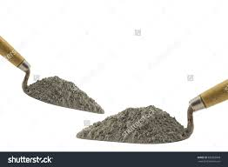
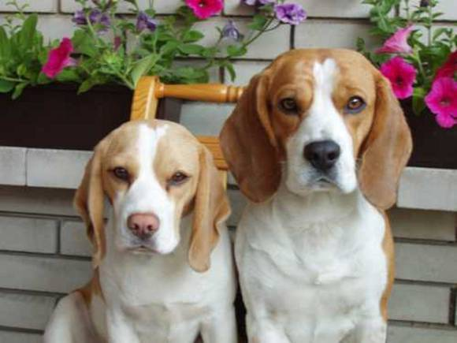
A B

- Choose the letter of the above pictures that represents a living thing______________________
- Give evidence that this is living

____________________________________________________________________________________________________________

- What contribution did Van Leeuwenhoek and Hooke have to the cell theory and why was it important?

- What are the 3 parts of the Cell theory?

- ________________________________________________________________________________________
- ________________________________________________________________________________________
- ________________________________________________________________________________________
- What “organisms” do scientists debate whether they are truly living or not?
________________________________________

- Label the animal cell below by writing the matching number next to the name of the organelle.
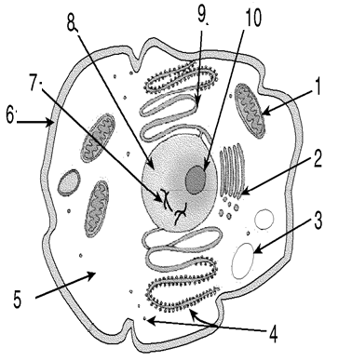
- Golgi Body _______
- Ribosome _______
- Cytoplasm _______
- Chromosomes _______
- Nucleus _______
- Vacuole _______
- Mitochondria _______
- Endoplasmic Reticulum _______
- Cell Membrane _______
- Nucleolus (not on test) __10__

- In which organelle is energy released in both the plant and animal cell? _____________________________________
- In which organelle does photosynthesis take place? ________________________________
- What are the main differences between an animal and plant cell? ________________________________________________________________________________________________________________________
________________________________________________________________________________________________________________________
- What special term do we us to describe how only some molecules can move across the cell membrane? _________________________________________________________
- Use the word bank to define the words:

cell wall cytoplasm vacuole cell membrane
golgi body chloroplast mitochondria lysosome
ribosomes nucleus endoplasmic reticulum

- __________________________________ Controls the movement of materials in and out of the cell.
- __________________________________ Surrounds the plant cell and gives it its shape.
- __________________________________ Jelly-like material that contains cell materials.
- __________________________________ Controls the cells activities, controls growth and reproduction.
- __________________________________ Processes food for energy and releases energy for the cell to use.
- __________________________________ Contains chlorophyll to help the plant cell trap sunlight to make food.
- __________________________________ A large round sac that stores water, food, wastes.
- __________________________________ A series of tubes throughout the cell that transport materials.
- __________________________________ Builds proteins that are used by the cell
- __________________________________ Packages the material in the cell and ships them out to the cell for use.
- __________________________________ Breaks down (digests) larger food molecules into smaller molecules

- List the levels of organization from simplest to most complex: Organ, organ system, cell, tissue

_____________________, ______________________, ________________________, _______________________

