Name: __________________________ Period _______________ Date__________________ HO # _______

Review Sheet for Weather Quiz # 2 –Layers of the Atmosphere, Transferring Heat, Wind and Water Cycle

The sun
Energy from the sun is the driving force behind all weather. The uneven heating of the surface of the earth causes temperature differences, which cause differences in air pressure, which causes wind.

There are three ways that heat is transferred:
Conduction: Heat energy is transferred through direct contact (moving particles make affect other moving particles)
Convection: Heat energy is transferred through liquids or gases. Hot air rises, cold air falls
Radiation: Heat energy is transferred by waves through empty space (like the rays of the sun)

Layers of the Atmosphere
The troposphere is where all of our weather occurs. As you increase elevation in the troposphere, the air temperature gets colder. As temperature increase, the molecules in a substance move faster (increase their motion). The stratosphere is where the ozone layer is located. The ozone layer protects us from the sun’s radiation (which can cause skin cancer).
As you increase elevation through all the layers of the atmosphere, air pressure decreases

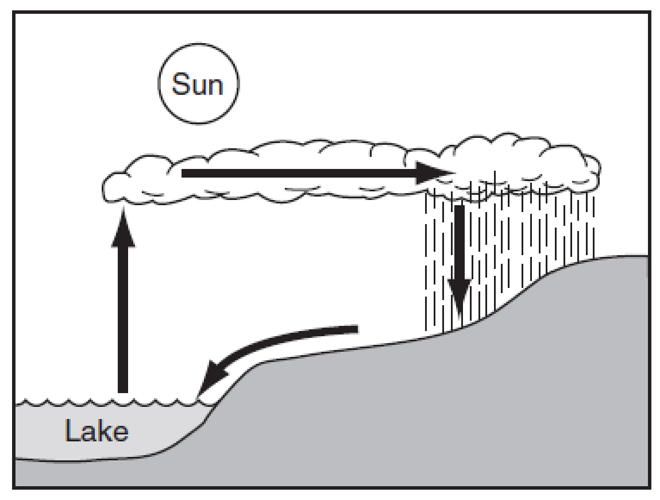
The water cycle has 5 components (processes) :
Evaporation – liquid to gas – water rises from surface of the earth
Condensation – Gas to liquid – CLOUDS form
Precipitation – water is returned to earth from the clouds
Run-off – due to gravity, water flows downhill
Transpiration – trees release water during respiration

Wind
Local winds are characterized by WHERE they come from. Land breezes blow from the land and sea breezes blow from the ocean. Global winds such as the Jet Stream blow for thousands of miles. The Jet stream blows from the west coast to the east coast of the United States. The Earth rotates and causes wind to NOT go in straight lines. The circular motion of the wind is called the Coriolus Effect.

Review - Weather Quiz
Troposphere – all WEATHER occurs in this layer of the atmosphere
Stratosphere = Location of OZONE layer – the Ozone layer protects Earth from UV radiation

Motion of molecules INCREASES as temperature INCREASES
Temperature at TOP of mountain is COLDER – High Altitude

As Altitude Increases – AIR pressure DECREASES
Breeze FROM Ocean = SEA BREEZE
Wind always blows from High Pressure to LOW pressure
All WEATHER in US moves towards the NORTHEAST (where WE Live!!)
Fast Moving BELT of air = JET Stream – West Coast to East Coast
CORIOLUS effect – Because the Earth is Spinning, the earth goes in a circular pattern called C E

SUN = Source of ENERGY for atmosphere
CONVECTION = hot RISES and Cold SINKS
RADIATION – Transfer of Heat Energy through Empty Space
Clouds = condensation
Trees = Transpiration

DRAW WATER CYCLE BELOW AND LABEL:

