- Genetics: The study of ____________________ and how ______________________________________________________________________________

What is a Trait? _________________________________________________________________

Traits are expressed ___________________________________
Examples: hair color and texture, skin color, etc… - EX -Tongue Rolling, Widow’s Peak, Attached Earlobes, Hitchhiker thumb, bent pinky finger (PHENOTYPES)

How are traits inherited?

Traits are ________________________________________found in the

___________________________________________________.

Chromosomes are ________________________________________________________________
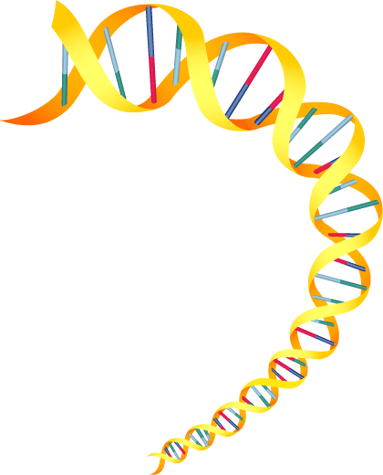
DNA is the ______________ for how living things develop and function

The DNA molecule looks _____________________________
The steps of the ladder are made of chemical compounds _________

The 4 bases are _________________, _______________,

_____________________, and _____________________

The bases are arranged in different ways to form different chemical messages that control different traits
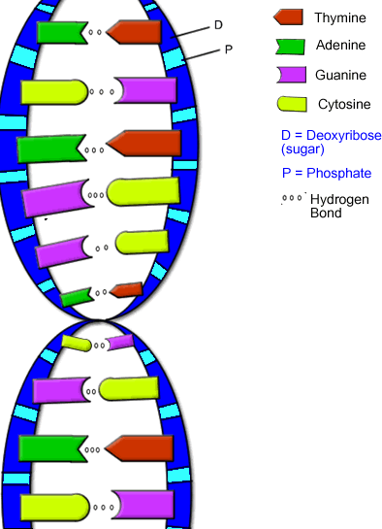
Adenine always pairs Identical twins are the only human beings who
______________________ have identical DNA

Guanine always pairs Everyone else on EARTH
has different DNA
_____________________ combinations that make us each
UNIQUE.

- Gregor Mendel: _____________________________________

He studied ________________ due to their ____________________.

Mendel concluded that traits occur _____________________________ not at random.

Each parent contributes one gene _____________ to the offspring

Therefore, offspring are _____ identical to their parents.

Parents can pass on one of two types of traits:
1. Dominant trait- _______________________________________
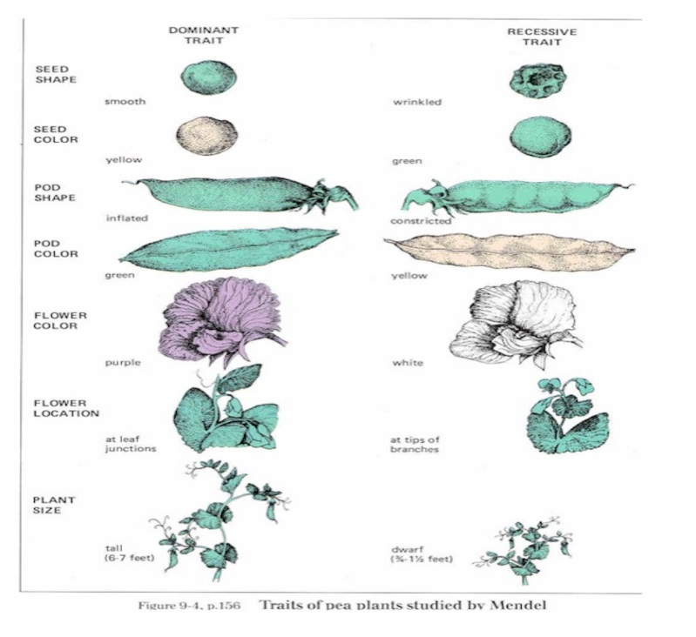
2. Recessive trait-___________________

 | DOMINANT TRAITS | RECESSIVE TRAITS
Eye Coloring
Vision
Hair
Facial Features
A capital letter represents a ________________ Tallness = _____

A small letter represents a ___________________ Shortness = ___

Remember, _____________________________________________________

III. Types of Traits
Pure Dominant- ________________________________________________

__________________________________________________________________

Pure Recessive- _________________________________________________

__________________________________________________________________

Heterozygote (hybrid)- __________________________________________

__________________________________________________________________

Genotype =  the Gene combinations | Phenotype=  the physical appearance
If you pair a TALL female with a short male it will look like this:

The child will be tall but will be a HYBRID or Heterozygous

Can we ever know if a Tall person has pure dominant tall genes (TT) or is a hybrid (Tt) for tallness?

It is impossible to know __________________________________________

__________________________________________________________________

IV Pedigree Chart

Reading a pedigree chart
=Female = Male

Shaded circles or squares Unshaded circles or squares

show the __________________ show the ___________________

- Here’s a pedigree for curly hair, which is a dominant trait…
- Punnett Squares
Shows the probability that a child will have a specific trait

Each box represents 25%

- First, the father’s genes are listed along the top of the Punnett Square and the mother’s genes are listed along the side
(Freckles (F) vs. No Freckles (f))
- Next, we fill in the boxes with the letters that represent the genes…
- In this example, offspring have a 100% chance of having freckles, but…
F F

f

f
- Freckles can be pure dominant or heterozygous, so two punnett squares are needed
- Blue-Eyed Father and Blue-Eyed Mother

b b

b

b
- Gender

In Females, the chromosome pair is XX
In Males, the chromosome pair is XY

Some human diseases are a result of genetic defects:
- Color blindness
- Tourette Syndrome
- Tay Sachs Disease
- Muscular Dystrophy
- Cystic Fibrosis
- Hemophilia
- Down Syndrome
- Dwarfism
- Albinism
- Mutations
Genetic “mistakes” that effect the way traits are inherited. (A change in a gene or chromosome)
If a mutation takes place in a body cell, it effects only the individual.
If it occurs in a sex cell, the mutation can be passed onto the offspring.
Usually caused by environmental factors such as chemicals, x-rays or radiation.

- Mutations may reduce the organisms chance of survival or reproduction.
- Some mutations are actually helpful and improve the chances of survival
- Seedless navel oranges are sweeter and juicier
- Potatoes that resist diseases that attack other potatoes
- Mutations provide variations in species and can result in brand new species (this is called evolution)

- Before body cells divide, the DNA code of the parent is duplicated and a copy is passed on to the new cells

- The new cells recognize the DNA code and determine how each trait is expressed.

